Mastering Embedded System Online Diploma

[www.learn-in-depth.com](http://www.learn-in-depth.com)

* First Term (Final Project 1)
* My Profile: [my progress page](https://www.learn-in-depth-store.com/account/blank-4)

[(learn-in-depth-store.com)](https://www.learn-in-depth-store.com/account/blank-4)

By: Eng. Abdelrahman Matarawy

Pressure Controller

Table of Contents

1. System Architecting/Design Sequence: 2

a. Case Study: 2

b. Method: 3

c. Requirement: 3

d. Space Exploration/ partitioning: 4

e. System Analysis: 5

I. Use Case Diagram: 5

II. Activity Diagram: 6

III. Sequence Diagram: 7

f. System Design (Modules): 8

I. Pressure Sensor Module: 8

II. Main Algorithm: 9

III. Alarm Monitor: 9

IV. Alarm Actuator: 10

2. By Run This Modules on TTool :(Analysis and Timing Diagram) 11

3. Simulation on Proteus: 12

a. Case1: 12

b. Case2: 13

# System Architecting/Design Sequence:

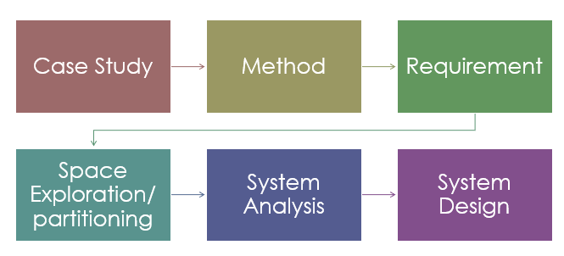

## Case Study:

* + - * The client Needs:
        + A pressure controller informs the crew of a cabin with an alarm when the pressure exceeds 20 bars in the cabin.
        + The alarm duration equals 60 seconds.

## Method:

* 1. we Use V Method which is Suitable in Our Project
  2. Software Testing Life Cycle
     1. It consists of a series of activities carried out by Testers methodologically to test your software product.
  3. Though STLC uses the term “testing”

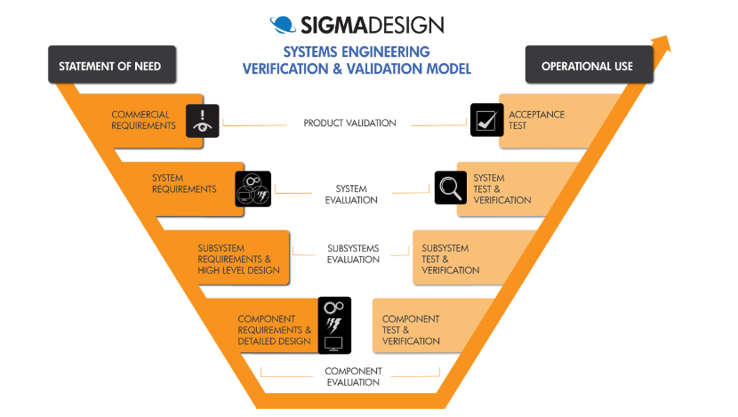

## Requirement:

1. Project Title Split into 2 Cases:
2. A pressure controller informs the crew of a cabin with an alarm when the pressure exceeds 20 bars in the cabin.
3. The alarm duration equals 60 seconds.

“Each One Split to Its Refinement”

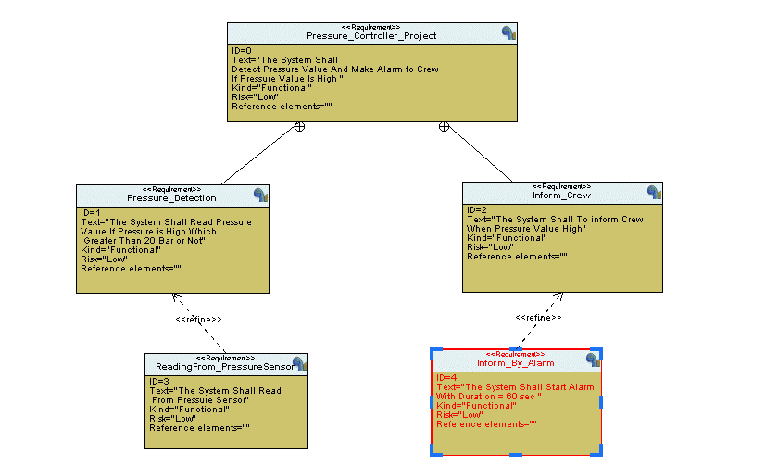

## Space Exploration/ partitioning:

* By Searching For optimal solution:
* We Found That STM32F103 Perfect Choice to Work On it as:
  + 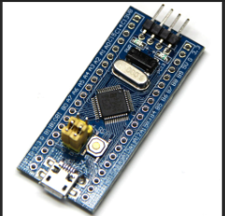Low Cost
  + Power Consume
  + Make Our Task with Good performance.
  + It Has Debug Circuit Built On it.

## System Analysis:

1. Use Case Diagram:
   * System boundary and main functions.
2. Activity Diagram:
   * Relations between main functions.
3. Sequence Diagram:
   * Communications between main system entities and actors.

### Use Case Diagram:

1. We Have Pressure Sensor as Actuator.
2. Reading This Value.
3. Send The Value to Main Code
4. Algorithm Of Main Send to Alarm Monitor If Pressure is Higher Than 20 Bar Or not.
5. If pressure High, The Alarm Monitor Will Send to Alarm Actuator to Start Alarm
6. 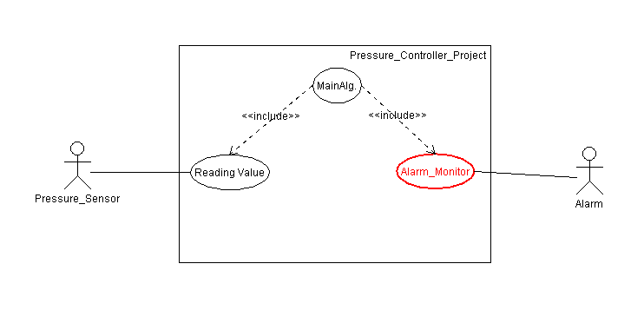While Alarm Starting It Continuous For 60 Sec
7. Then Alarm Actuator Off

### Activity Diagram:

* 1. Reading Pressure Value from Pressure Sensor
  2. Check If Pressure Value Greater than threshold Or Not
  3. In Case Greater than Make Action with Start Alarm
  4. Send signal to start alarm.
  5. Waiting For Alarm Duration
  6. Send Signal to Stop Alarm
  7. 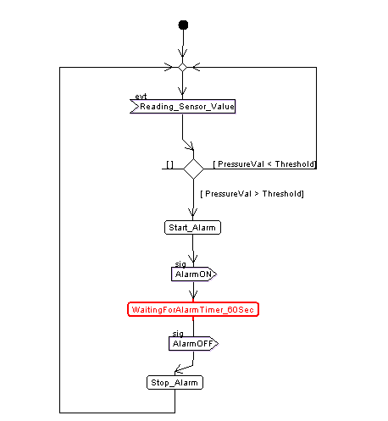Return To read Value again.

### Sequence Diagram:

* 1. Sensor Read 12 and send it to main.
  2. Main compare with threshold
  3. Reading again
  4. Sensor read 22 which greater than threshold.
  5. Main send to start alarm.
  6. Waiting for alarm duration
  7. Main stop alarm
  8. 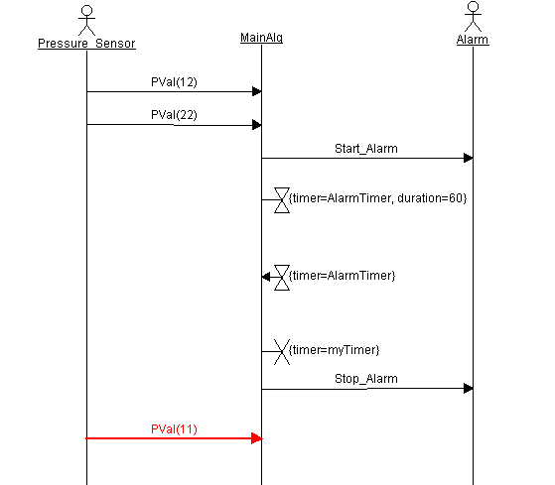Polling to sensor again

## A close-up of a check Description automatically generatedSystem Design (Modules):

### Pressure Sensor Module:

1. Start with Initialized Module.
2. In Reading State:
   1. First Sensor Start to Polling to Read or Detect Pressure.
   2. Second Sensor Send This Read to Second Module to Make Calculation and Check.
3. Set Timer to Polling on Reading Pressure

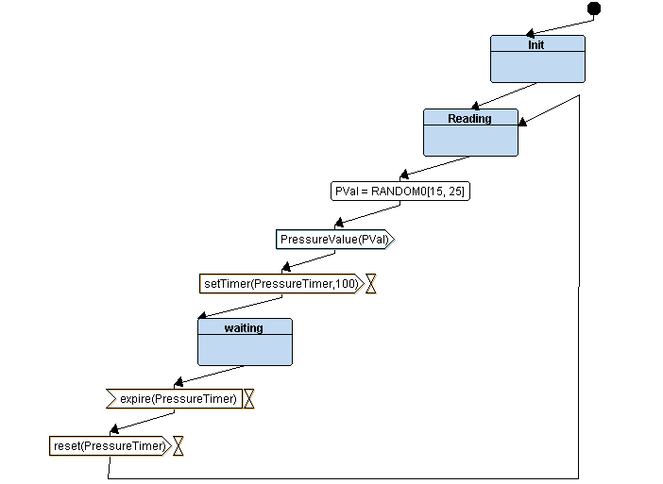

### Main Algorithm:

* 1. First Receive Signal and Check Value:
     1. In Case Pressure Value Greater Than Threshold (20 Bar), Send High Pressure Detected Signal to Alarm Monitor Modules and Back to Read Value Again.
     2. 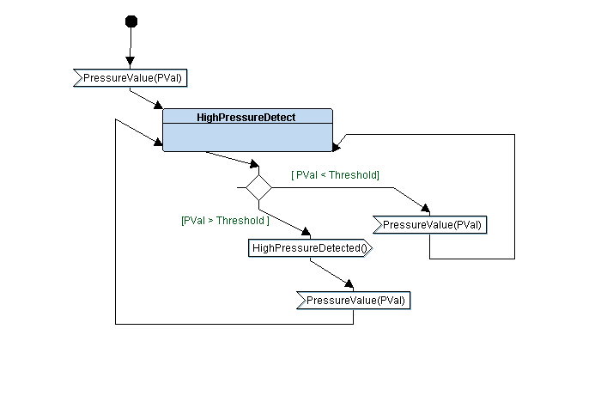In Case Pressure Value Smaller Than Threshold (20 Bar), Just Stay Reading Value Again.

### Alarm Monitor:

* 1. After Receive Signal with High Pressure:
     1. Send Signal to Alarm Actuator to Start Alarming.
     2. Waiting For Period of Time (60 sec), Then Send Stop Signal.
  2. In Case of not Receiving High Pressure:
     1. Send Signal to Alarm Actuator to Stop Alarming.

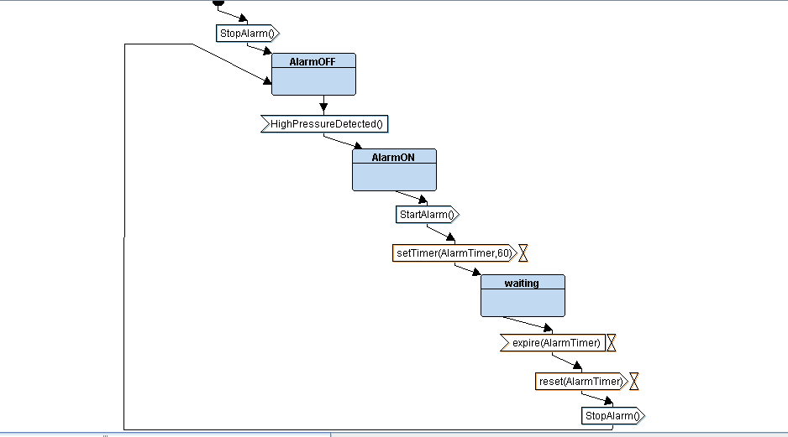

### Alarm Actuator:

* 1. Stay in Waiting State Until Receive Signal.
     1. If Signal Start Alarm Make Led on for 60 sec, Then Turn it Off and Back to Receive Another Signal Again.
     2. 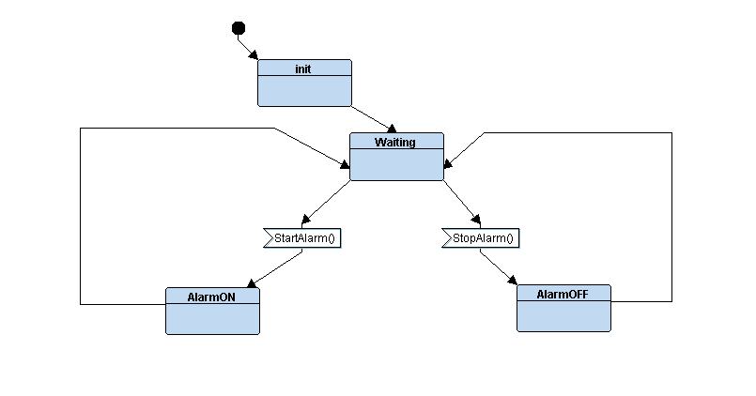If Signal Off Alarm Just Make Led Off and Back to Receive Another Signal Again.

# By Run This Modules on TTool :(Analysis and Timing Diagram)

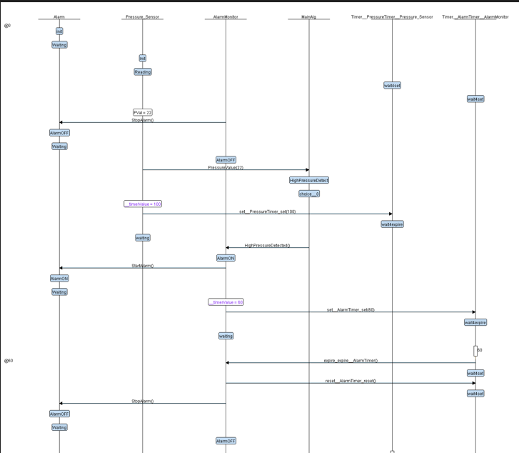

# Simulation on Proteus:

## Case1:

* If the pressure Value is less than Threshold (20 bar), the Led is off.

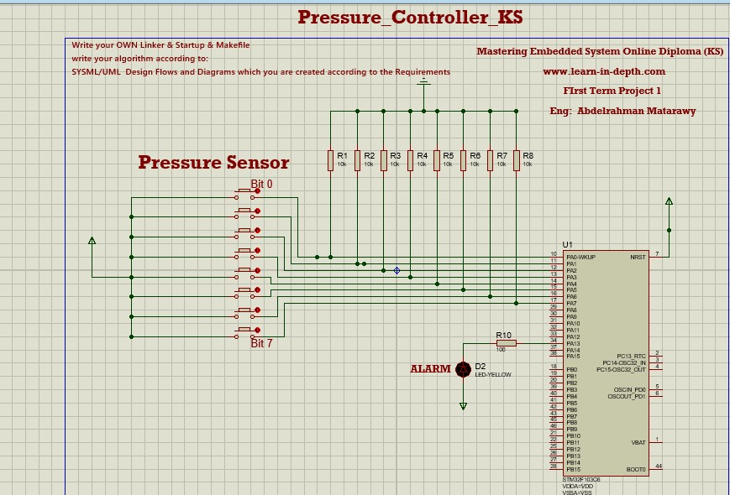

## Case2:

* If the Pressure is bigger than 20 bar, the LED is on for 60 Second and Off Again.

